Name: _____________________ Class:__________ Date:__________
Instructions: Write answers in the right-hand column. Score: ___________ / 43 marks

Section A— Multiple choice (10 marks)

 | Which of the following is considered evidence to support the Big Bang model of the origin of the universe?  - cosmic microwave background radiation  - cosmological red-shift  - the relatively even distribution of galaxies  - both A and B above | D | 1
 | In 1838, Friedrich Bessel was the first person to measure the distance to a star using the parallax method. He measured the distance to a star called 61 Cygni to be 3.5 parsecs. Convert this distance to light-years.  A 1.0 l.y.  B 3.5 l.y.  C 11.4 l.y.  D 37 l.y. | C | 1
 | Alpha Centauri has an apparent magnitude of −0.27 whereas the apparent magnitude of Alpha Crucis is 0.77. Which star appears brighter when observed from Earth?  A Alpha Centauri  B Alpha Crucis  C both stars have the same brightness  D there is not enough information to answer this question | A | 1
 | A black hole can be detected by:  A gravitational lensing  B its effect on another star in a binary pair  C both A and B above  D it is impossible to detect a black hole | C | 1
 | Which of the following is NOT an assumption or prediction of the steady state model of the universe?  A The universe extends infinitely in all directions.  B The universe has always been in roughly the same form as it is today.  C Stars and galaxies are distributed roughly evenly across the night sky.  D The universe is expanding. | D | 1
 | The spectral class of a star gives information about its:  A temperature  B composition  C distance from Earth  D both A and B above | D | 1
 | A typical neutron star has a mass of 4 × 10³⁰ kg and a volume of 5 × 10¹² m³. Calculate its density.  A 8 × 10¹⁷ kg/ m³  B 1 × 10¹⁸ kg/ m³  C 4 × 10³⁰ kg/ m³  D 2 × 10⁴³ kg/ m³ | A | 1
 | Define abiogenesis.  A The theory that life came to Earth in the form of micro-organisms within a comet or meteorite.  B The development of life from non-living materials.  C The study of life in other parts of the universe.  D The formation of life in a laboratory experiment. | B | 1
 | Which of the following did not help the development of life as we know it on Earth?  A The Sun and Moon created ocean tides.  B The Earth’s orbit maintains temperatures in a range suitable for life.  C The Earth has a 24-hour day.  D Meteorite impacts caused worldwide extinctions of dominant species. | C | 1
 | Identify the main source of oxygen in the Earth’s atmosphere.  A Meteorites  B Volcanic eruptions  C Cyanobacteria  D Comets | c | 1

Section B— Short answer (23 marks)

- ` | a Define orbit.  b Identify three objects that are in orbit and, in each case, what they orbit. | a Orbit means to revolve around another object.  b Planets orbit the Sun, comets orbit the Sun, asteroids orbit the Sun, moons orbit planets, artificial satellites orbit planets, stars can orbit each other (any 3). | 4
 | Compare and contrast the terms absolute magnitude and apparent magnitude. | Both terms refer to the brightness of a star.  Apparent magnitude refers to the brightness of the star when viewed from Earth whereas the absolute magnitude is the brightness of the star if it was 10 parsecs from Earth. | 2
 | Recall the definition of a parsec. | A parsec is the distance a star would need to be from our Sun if it was to have a stellar parallax of exactly 1 arcsecond. | 1
 | Describe the process by which a main sequence star turns into a black dwarf. | When the hydrogen in the core runs out, the star cools and forms a red giant.  When the helium in the core runs out, the outer layers of the star escape to form a planetary nebula.  The remaining core cools to form a white dwarf, and then cools further to form a black dwarf. | 4
 | Recall the products of the following fusion reactions:  a proton + proton reaction within a star.  b helium-3 + helium-3 | a deuterium nucleus, positron, neutrino, gamma ray.  b helium-4, 2 hydrogen nuclei (i.e. protons), energy | 4
 | Explain why stellar parallax cannot be used to measure the distance to other galaxies. | Other galaxies are so distant that their parallax is too small to be measured. | 1
 | Explain the significance of the Miller–Urey experiment. | It showed that amino acids, which are the building blocks of proteins and DNA, could be formed from a mixture of inorganic gases similar to Earth’s early atmosphere. | 1
8 | Explain why most scientists no longer accept the Steady State model. | It cannot explain the Hubble red shift data or cosmic microwave background radiation. | 1
9 | Explain why oxygen did not appear in the Earth’s atmosphere when cyanobacteria started to produce it. | Oxygen may have reacted with materials in the Earth’s crust to form oxides. | 1
10 | Explain what the ‘habitable zone’ is and why being in it makes it more likely that life can evolve on a planet. | The habitable zone is range of planetary orbits which keep temperatures on the planet within a certain range.  Being in the habitable zone means that water is in liquid form, photosynthesis is efficient and the temperatures are not too hot to live. | 4

Section C— Thinking scientifically (10 marks)

 | The table below shows the colours and temperatures of stars of different spectral class.  What is the colour of a star of spectral class O?  A blue  B blue-white  C orange  D red | A | 1
  Spectral class | Temperature (°C) | Colour
  O | 50 000–28 000 | Blue
  B | 28 000–10 000 | Blue-white
  A | 10 000–7500 | White
  F | 7500–6000 | White-yellow
  G | 6000–4900 | Yellow
  K | 4900–3500 | Orange
  M | 3500–2000 | Red
 | The Sun has a temperature of 5500°C. Use the table in question 1 to identify its spectral class.  A A  B B  C O  D G | d | 1
 | According to the Hertzsprung–Russell diagram below, what is the range of possible absolute magnitudes of a supergiant star?  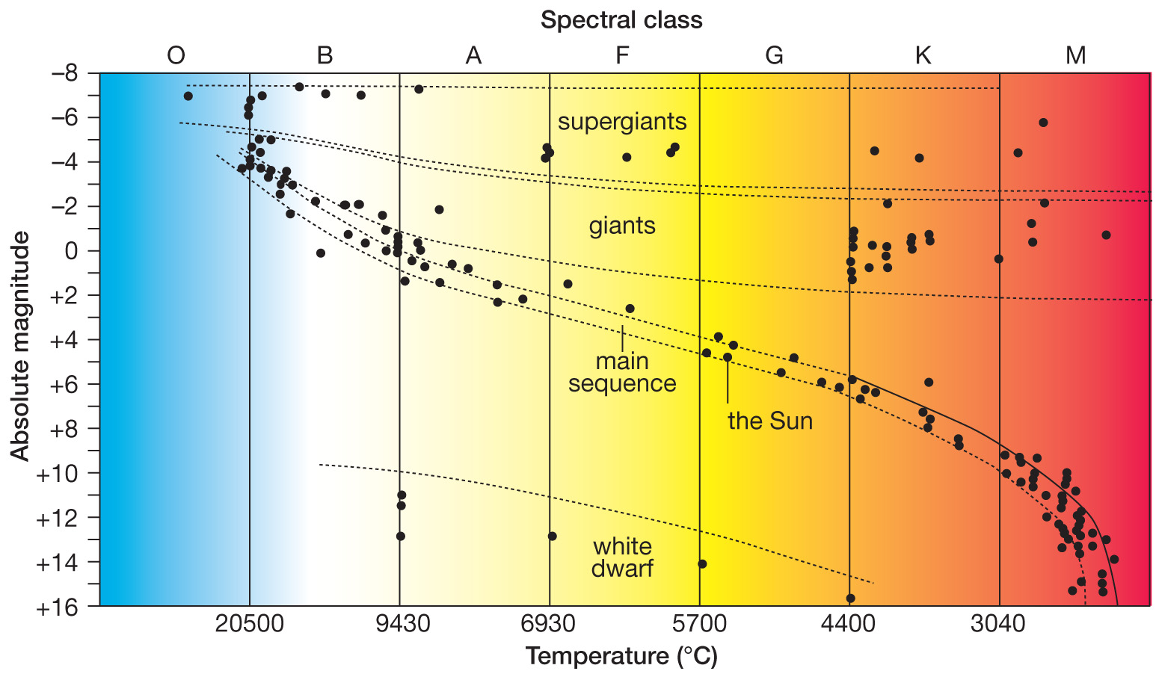  A –10 to –16  B –8 to –4  C –4 to +2  D +10 to +16 | B | 1
 | Polaris, otherwise known as the Pole Star, has a spectral class of F and an absolute magnitude of 3.6. According to the Hertzsprung–Russell diagram shown in question 3, it would be classified as a:  A giant  B main sequence star  C super giant  D white dwarf | B | 1
 | The table below shows the density of various metals.  If 1 kg of each of these metals was shaped into a perfect sphere, which sphere would have the largest diameter?  A iron  B lead  C gold  D all 3 spheres would have the same radius | A | 1
  Metal | Density (g/cm³)
  Iron | 7.87
  Lead | 11.34
  Gold | 19.32
 | Mercury is a liquid at room temperature and has a density of 13.55 g/cm³. Which of the metals in the table in question 5 would float in mercury?  A iron  B lead  C gold  D both iron and lead | D | 1
The following information is for questions 7, 8 and 9.
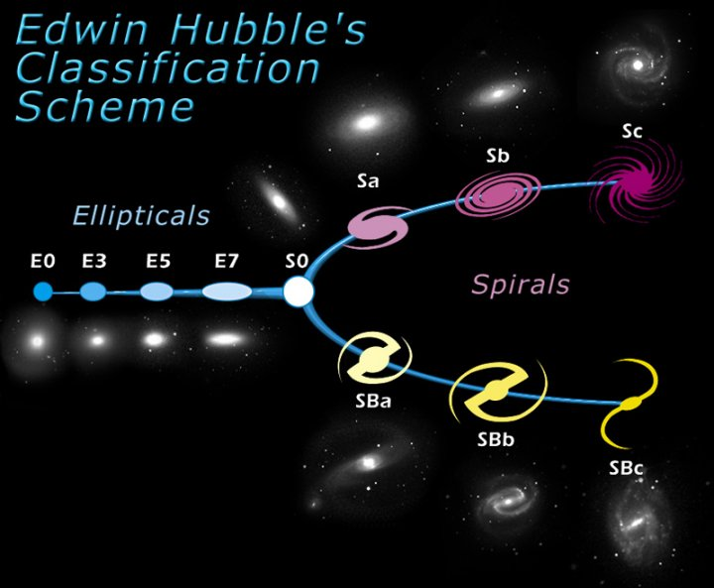
The diagram above shows the Hubble classification system which classifies galaxies as elliptical (E), spiral (S) or barred spiral (SB).
 | Using the Hubble classification system, which one of the following galaxies would be most likely to be classified as spiral? | A | 1
  A  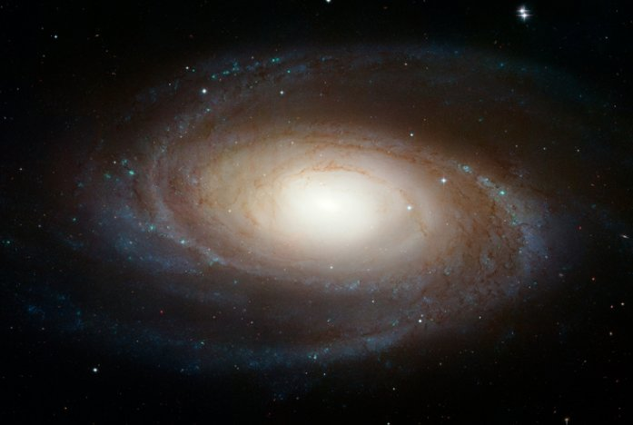 | B  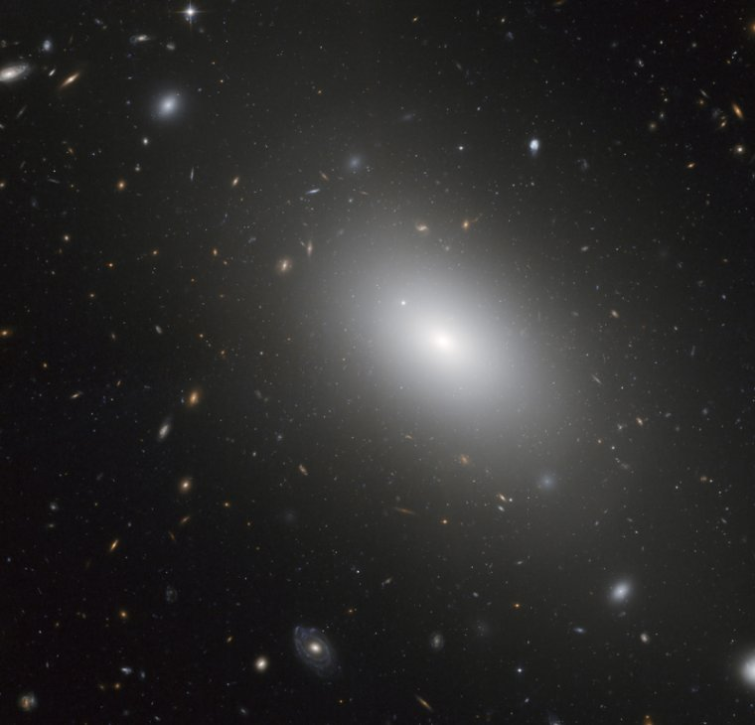
  C  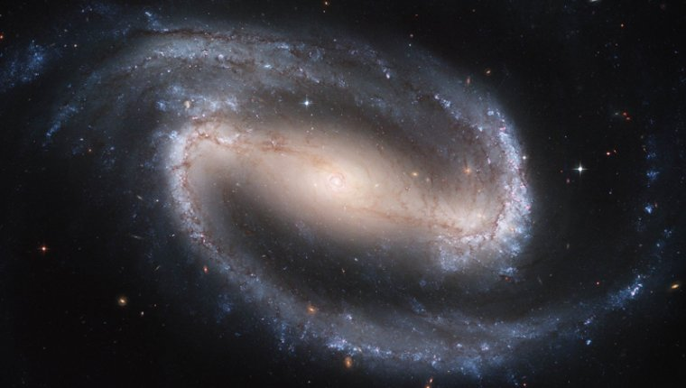 | D  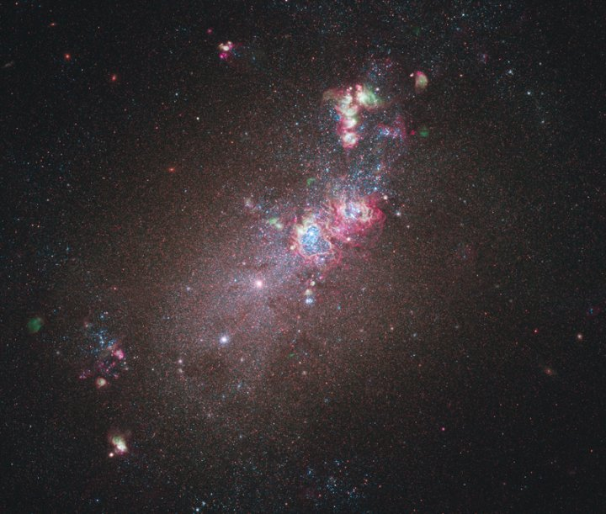
 | Using the Hubble classification system, which one of the following galaxies would be most likely to be classified as barred spiral? | C | 1
  A | B
  C | D
 | Using the Hubble classification system, which one of the following galaxies would be most likely to be classified as elliptical? | B | 1
  A | B
  C | D
 | Which of the following observations does NOT support the Giant Impact Hypothesis of the Moon’s formation?  A Rocks collected during the Apollo Moon landings have identical oxygen isotope ratios to rocks on Earth.  B The composition of the lunar rocks suggests that at one time most of the Moon was covered by molten rock.  C Measurements of the Moon’s rotation suggest that, if it has an iron-rich core, this core must be very small.  D The iron oxide content of the Moon is 13% which is significantly more than Earth’s (8%). | D | 1

